The Embassy of Greece and the National Gallery of Art
Present
A Tribute to Greek Filmmaking Master
Michael Cacoyannis
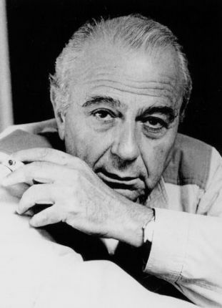
May 20 and 26, 2012
Greek director Michael Cacoyannis (1921–2011) was internationally renowned not
only as a film, theater, and opera director—he was also an accomplished
writer, actor, and translator, a designer of settings and costumes, a
producer, and all-around man of the contemporary theatrical arts. He worked on
many of the world's great stages for more than 60 years. While known for his
productions of the plays of Euripides, he could masterfully adapt modern
writers including O'Neill, Chekhov, and of course his Greek contemporary Nikos
Kazantzakis, author of Zorba the Greek.
Cacoyannis' final film, The Cherry Orchard, and his lauded adaptation of Euripides' Electra
are presented as a tribute to the director's career (he died last year).
With thanks to the Greek Film Center and the Michael Cacoyannis Foundation.
More information on Cacoyannis at: http://www.mcf.gr/en/micheal_cacoyannis/Biography/
The Cherry Orchard
Sunday, May 20, 4:00 p.m.
At the start of the last century, a family of Russian aristocrats on the verge
of losing their estate is powerless to prevent the loss. Anton Chekhov's sad
and satiric drama about the decline of the landed gentry is given a novel
treatment in Cacoyannis' interpretation, as he infers new details about the
period and the main characters—Charlotte Rampling as Ranevskaya and Alan Bates
as Gayev. Cast members probe their own characters' motives, while the
mise-en-scène points to the director's careful study of the art of the period.
(1999, 35 mm, 141 minutes)
Electra
Saturday, May 26, 3:30 p.m.
Introduction by Martin Winkler
A rocky landscape photographed in striking black and white by Walter Lassally
becomes Electra's extended stage, completely open and exposed but also hermetic and eternal.
Euripides, wrote Cacoyannis, had an "extraordinary
technique of opening up the action to establish a dramatic situation and then
focusing in on his characters at such close range that you feel you are
looking into their souls." Cacoyannis achieves his theatrical yet blunt
stylization through the formal movements of his actors, "and an emphasis he
places on significant actions…and the sudden use of turmoil in nature to
heighten the violence"—Roger Manvell. (1962, 35 mm, Greek with subtitles, 120’).
http://www.nga.gov/programs/film/Cacoyannis.shtm
All films are presented free of charge in the East Building Auditorium of the National Gallery of Art.
Seating is first come, first served.
Gallery Location and Hours
The National Gallery of Art, located on the National Mall between 3rd and 7th Streets at Constitution Avenue NW, is open Monday through Saturday from 10:00 a.m. to 5:00 p.m. and Sunday from 11:00 a.m. to 6:00 p.m.
http://www.nga.gov/ginfo/ebmaps.shtm#concourse
See also area map, public transportation, and parking <http://www.nga.gov/ginfo/area_map.shtm>

